**PL/SQL – Practice Questions**

Use STUDENT ADMINISTRATION (SA) database for below PL/SQL questions. SA is used to manage a school’s course offerings as delivered by instructors in many classes over time.

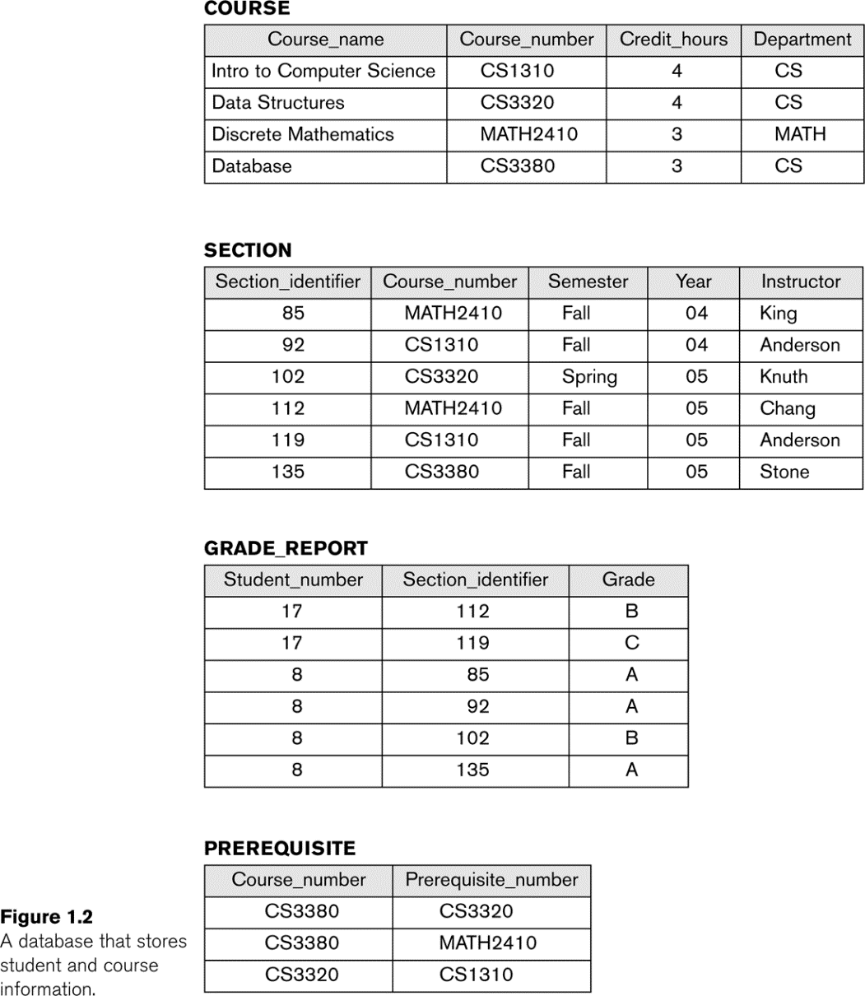

Assume STUDENT table is added to SA database.

STUDENT(Student_number, Fname, Lname, Major, GPA)

1. Create a standalone procedure to enroll a student to a particular class. Accept Student_number and Section_identifer as input parameters. Grade will be initially NULL.

2. Write a triggger that updates the GPA attribute on Student table as Grade attribute changes on Grade_Report table. Assume following “Grade Points per Semester Hour” values.

A=4, B=3, C=2 and D=1.

3. Write an anonymous block that finds total number of students enrolled to a given course section. (Section_identifier can be hardcoded).

4. Write a stored procedure that defines a new section for a particular course. Procedure should receive the Instructor Name, Course Number, Semester and Year as input parameters. Section_identifier should take an auto-increment value and procedure should return this value to the caller.

5. When a student tries to enroll to a course, check if they have completed all prerequisites. Write a trigger that implements the check and do not allow registration if prerequisites are not completed. Consider only one level pre-requisite check. (i.e. for CS 3380, prerequisites are CS3320 and MATH2410)